ECE 1352 Term Paper

Phase Noise Analysis of VCO and Design Approach to LC VCOs

University of Toronto
Prof. K. Phang

Nov. 12 2001
By
Fang Fang

Phase Noise Analysis of VCO and Design Approach to LC VCOs
Integrated voltage controlled oscillators are commonly used functional blocks in modern radio frequency communication systems and used as local oscillators to up- and down-convert signals. Due to the ever-increasing demand for bandwidth, very stringent requirements are placed on the spectral purity of local oscillators. Recently, there has been some work on modeling jitter and phase noise [1]-[4] in VCOs and efforts to improve phase-noise performance of integrated LC VCOs have resulted in a large number of realizations. Despite these endeavors, design and optimization of integrated LC VCOs still pose many challenges to circuit designers as simultaneous optimization of multiple variables is required. This is especially important when number of design parameters is large, as any optimization methods of CAD tools unjustifiably exploits the limitations of the model used.
This paper covers phase noise analysis methods and design approaches using graphical optimization method to optimize phase noise subject to design constraints such as power dissipation, tank amplitude, turning range, start up condition and diameters of spiral inductors.
- Characterization of phase noise and analyzing models
Phase noise is usually characterized in terms of the signal sideband noise spectral density. It has units of decibels below the carrier per hertz (dBc/Hz) and is defined as
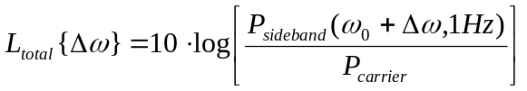 ( )
where P_{sideband}(ω₀+Δω, 1 Hz) represents the signal sideband power at a frequency offset of Δω from the carrier with a measurement bandwidth of 1 Hz.
  - Leeson-Cutler phase noise model
The semi-empirical model proposed in [5], known also as the Leeson-Cutler phase noise model, is based on linear time invariant system assumption for LC tank oscillators. It predicts the following equation for L{Δω}:
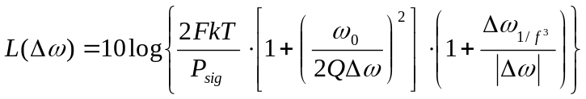 ( )
Where F is an empirical parameter (often called the “device excess noise number”), k is Boltzman’s constant. T is the absolute temperature, P_{sig} is the average power dissipated in the resistive part of the tank, ω₀ is the oscillation frequency, Q is the effective quality factor of the tank with all the loadings in place. Δω is the offset from the carrier and Δω_{1/f}³ is the frequency of the corner between 1/f³ and 1/f² region ( as shown in Fig. 1). Unfortunately, we have some difficulties in predicting phase noise performance of VCO with this equation, which mainly comes from the fact that F and Δω_{1/f}³ are fitting parameters and we cannot calculate them a priori.
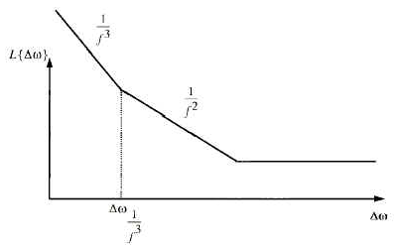
Fig. 1 Typical plot of the phase noise of an oscillator versus offset from carrier
  - Linear Time Invariant (LTI) approach
This method ([3]) treats oscillator as a feedback system and consider each source noise as an input X(jω) ( Fig. 2). The phase noise at the output is a function of : 1) sources noises in the circuit and 2) how much the feedback system rejects ( or amplifies) various components of noises.
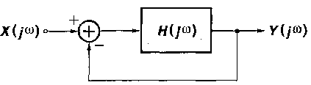
Fig. 2 linear oscillatory system
The noise power spectral density is shaped by
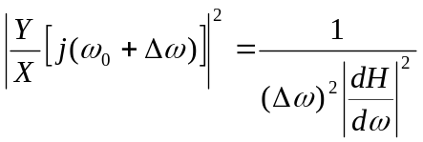 ( )
Thus, we can get the output noise spectral density response from equation (3). The main problem with this approach is that it is a first-order analysis of a linear oscillatory system that is not the case in actual oscillators. It is incapable of making accurate predictions of phase noise performance in VCOs.
  - Linear Time Variant (LTV) approach
This method ([4]) first introduces a special function: ISF function which describes how much phase shift results from applying a unit impulse at any point in time, such that phase shift response to a unit impulse is expressed as
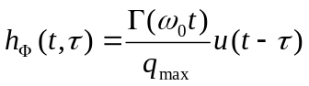 ( )
where, Γ(ω₀t) is the ISF function of the output waveform and q_{max} is the maximum charge offset across the capacitor. The total excess phase due to a noise current can therefore be described by the expression:
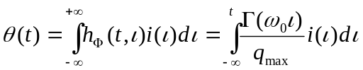 ( )
We can use phase modulation approach to convert phase to voltage and get the sideband power density as follows:
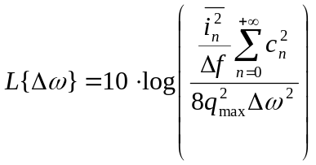 ( )
Where, 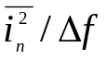is the power spectral density of input noise current. c_{n} is the coefficient of Fourier transform of ISF function . Δω is the frequency shift from carrier frequency.
LTV method is not only a good method to predict phase noise performance, but gives design insights in optimization of VCO. We will apply this method to explain a design approach to optimizing phase performance of LC VCO.
2. LC VCO design method
  - Two modes of operation
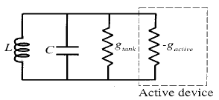
Fig. 3 Steady-state parallel LC oscillator model
Fig. 3 shows the model for a parallel LC oscillator in steady state, where g_{tank} represents the tank loss and –g_{acitve} is the effective negative conductance of the active devices that compensate the losses in the tank. Two modes of operation, named current- and voltage-limited regimes, can be identified for a typical LC oscillator considered the bias current as the independent variable [5]. In the current limited regime, the tank amplitude V_{tank} linearly grows with the bias current according to V_{tank}=I_{bais}/g_{tank} until the oscillator enters the voltage-limited regime. In the voltage-limited regime, the amplitude is limited to V_{limit}, which is determined by the supply voltage and/or a change in the operation mode of active devices (e.g., MOS transistors entering triode region). Thus, V_{tank} can be expressed as
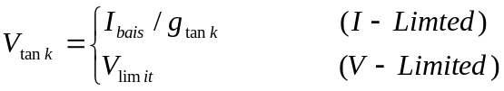 ( )
These two modes of operation can be viewed from a different perspective, by using the tank inductance L as the independent variable instead of I_{bias}. The tank energy E_{tank} is defined as E_{tank}=CV²_{tank}/2. V_{tank} can be expressed in terms of E_{tank}, i.e.
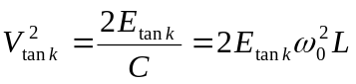 ( )
where, 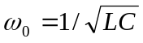 is the oscillation frequency. The tank amplitude grows with L for given E_{tank} and ω₀. While being the same as the current-limited regime, we refer to this mode as inductance-limited regime when L is the independent variable. So V_{tank} is rewritten as
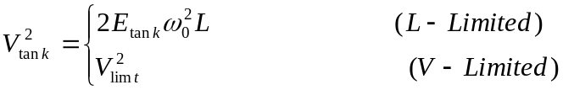 ( )

  - Design Strategy
- Design Topology
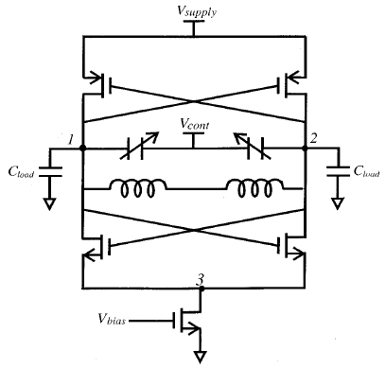
Fig. 4 VCO core schematic
Fig. 4shows an example LC VCO to demonstrate the optimization process. There are twelve initial design variables associated with this specific oscillator: MOS transistors dimensions (W_{n}, L_{n}, W_{p} and L_{p}), geometric parameters of on-chip spiral inductors (metal width b, metal spacing s, number of turns n, and diameter d), maximum and minimum values of the varactors (C_{v,max} and C_{v,min}), load capacitance (C_{load}) and tail bias current in the oscillator core ( I_{bias}). The number of independent design variables can be reduced to six through proper design considerations.
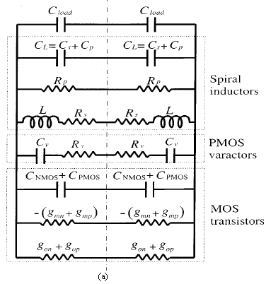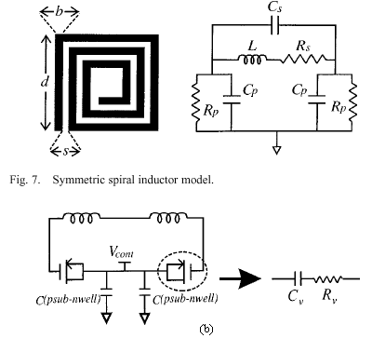
Fig. 5 (a) Equivalent oscillator model
(b) Symmetrical spiral inductor model and LC tank with MOSCAP varactor
The equivalent circuit model of the oscillator is shown in Fig. 5,where the broken line in the middle represents either the common mode or ground. The symmetrical spiral inductor model with identical RC loading on both terminals is used as a part of the tank model.
The frequently appearing parameters in optimization are the loss g_{tank}, effective negative conductance -g_{active}, tank inductance L_{tank}, and tank capacitance C_{tank} of Fig. 3, given by
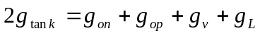 ( )
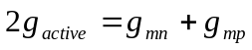 ( )
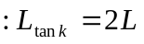 ( )
( )
respectively, where g_{L} and g_{v} are the effective parallel conductance of the inductors and varactors, respectively.
- Design Constraints
Design constraints are imposed on phase noise (which is the main goal of optimization), power dissipation, tank amplitude, frequency tuning range, startup condition, and diameter of spiral inductors. First, the maximum power constraint is imposed in the form of maximum bias current I_{max} drawn from a given supply voltage, i.e.
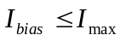 ( )
Second, the tank amplitude is required t be larger than a certain value, _{Vtank,min} to provide a large enough voltage swing for the next stage:
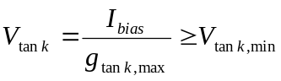 ( )
Third the tuning range of the oscillation frequency is required to be in excess of a certain minimum percentage of the enter frequency ω, i.e.
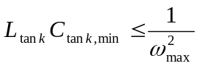 ( )
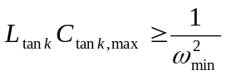 ( )
Fourth, the start-up condition with a small-signal loop gain of at least α_{min} can be expressed as
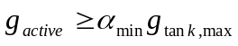 ( )
where the worst-case condition is imposed by g_{tank,max}.
Finally, a maximum diameter is specified for the spiral inductor as d_{max}, i.e.
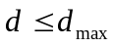 ( )
- Phase noise in this topology
According to LTV analysis, phase noise is given by
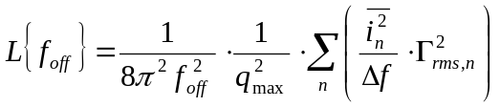 ( )
where f_{off} is the offset frequency from carrier frequency. The 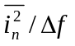 term represents equivalent differential noise power spectral density due to drain current noise, inductor noise, and varactor noise. They are expressed as
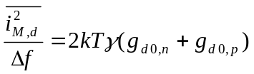 ( )
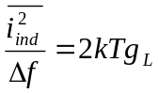 ( )
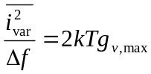 ( )
where γ∼2/3 and γ∼2.5 for long and short channel transistors, respectively. It can be proved that drain current noise is the dominance among the three noise sources [7]. By taking only drain current noise term into account in (20), replace q_{max} with 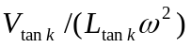, and g_{d0}=2I_{drain}/(L_{channel}E_{sat}) for short channel transistors, Γ²_{rms}=1/2 was used for pure sinusoidal waveform, phase noise can be expressed as:
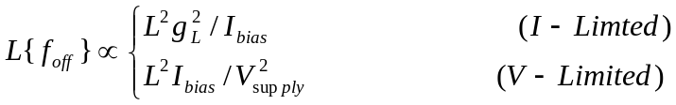 ( )
This equation for phase noise leads to a design strategy for phase-noise optimization.
- Design considerations for inductance
According to equation (24), for a given bias current, phase noise increases with an increasing L in the voltage-limited regime, which corresponds to waste of inductance. Equation (24) also indicates that for a given inductance L, phase noise increases with the bias current in the voltage-limited regime, inducing waste of power. For a typical on-chip spiral inductors, the minimum effective parallel conductance g_{L} for a given inductance L decrease with an increasing inductance when the diameter of the inductor is constrained as in (19). And the factor L²g²_{L} increases with an increasing inductance. Thus, for a given I_{bias}, phase noise increases with the inductance in the inductance-limited regime and a smaller inductance results in a better phase noise.
So the design strategy for the VCO is summarized as: find the minimum inductance that satisfies both the tank amplitude and startup constraints for the maximum bias current allowed by the design specifications.
- LC VCO optimization via graphical methods
At the beginning, twelve design variables are reduced to six. First, for power consumption constraint (14), I_{bias} is set to I_{max}. Second, for MOS transistors, channels lengths Ln and Lp are set to the minimum allowed by process to reduce patristic capacitance and achieve the highest transconductance. Symmetrical active circuit with g_{mn}=g_{mp} is used as to reduce the 1/f³ corner frequency [4], which establish a relationship between W_{n} and W_{p}. Therefore, MOS transistors introduce only one independent design variable, W_{n}. Third, MOSCAP varactors introduce only one design variable C_{v,max} since in a typical varactor, the ratio C_{v,max}/C_{v,min} is primarily determined by underlying physics of the capacitor and remains constant for a scalable layout. Fourth, the size of the output driver transistors can be preselected so that they can drive a 50- load with a specified output power with the worst-case minimum tank amplitude of V_{tank,min} . This results in a specific value for C_{load}, excluding it from the set of design variables. Table 1 shows the independent variables and table 2 shows an example of design constraints.

Table. 1 six independent variables
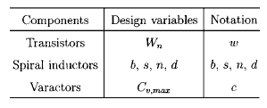
Table. 2 an example of design constraints
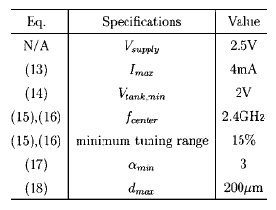
In this section, the value of inductance L is fixed to show how feasible design points in cw (capacitor, width of transistors) plane can be identified. Set L equals to 2.7nH. The geometric parameters of inductance such as b, s, n and d are chosen to minimize g_{L}.
All the design constraints (from (14) to (18)) are visualized in cw plane (Fig. 6). Where w (width of NMOS transistor) is in micrometers and c (value of varactor) is in picofarads The tank amplitude line is the loci of the cw points resulting in a tank amplitude of V_{tank,min} =2 V. Points below this tank amplitude line correspond to larger than 2 V. The broken line with one dash and three consecutive dots represents the regime-divider line, below which the oscillation occurs in the voltage-limited regime with the tank amplitude of V_{limit}=V_{supply}=2.5 V. The tr1 and tr2 lines are obtained from (16) and (17), respectively. A tuning range of at least 15% with a center frequency of 2.4 GHz is achieved if a design point lies below the line and above the line. The startup line is obtained from (18). The small-signal loop gain is over α _{min} =3 on the right-hand side of the startup line to guarantee startup. The shaded region in Fig. 6 satisfies all the constraints in (15) to (18) and therefore represent a set of feasible design points.
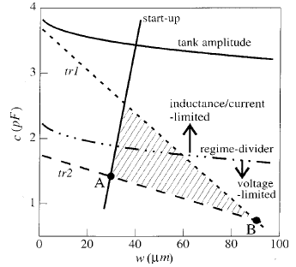
Fig. 6 design constraints in cw plane
We want to select the value of L as small as possible. But the L-reduction will translate the tank amplitude line downward and the startup line to the right, shrinking the feasible design area in the cw plane. For g_{L} in excess of a certain critical value, either the minimum tank amplitude constraint or the startup constraint will be violated. The inductance corresponding to this critical g_{L} is the optimum inductance L_{opt}. With L= L_{opt}, there exists only a single feasible design point in the cw plane, which lies on either the tank amplitude line or the startup line.
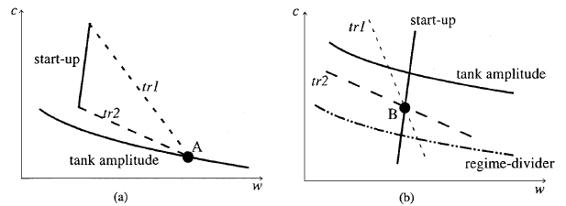
Fig. 7 (a) L-reduction limited by the tank amplitude constraints (b) L-reduction limited by the startup constraints

If the tank amplitude limit is reached first, the single feasible design point lies on the tank amplitude line at L= L_{opt}, as shown in Fig. 7(a). This unique design point in the cw plane represents the optimum c and w. On the other hand, when the startup constraint becomes active first, the region of feasibility will shrink to a single point B located on the startup line, as shown in Fig. 7(b).
- Summary of optimization process
This design approach can be summarized as follows:
⒜Set bias current to I_{max}, and pick an initial guess of for inductance value.
⒝find the inductance that minimize g_{L}
⒞plot design constraints in the cw plane suing the selected inductance
⒟If there are more than one feasible design points in the cw plane, decrease the inductance and repeat until the feasible region shrinks to one point. The single point in the cw plane represents the optimum c and w and the corresponding L is the optimum inductance.
- Conclusion
Three phase noise models and the comparisons among them are presented in this paper. A design strategy centered around an inductance selection is described by an insightful graphical method to minimize phase noise subject to several constraints imposed on power, tank amplitude, tuning range, startup, and diameter of spiral inductors. Instead of describing a specified circuit design, it gives a unified approach to LC VCO design.
- References
[1] T.C. Weigandt, B.Kim, and P. R. Gray, “Analysis of timing jitter in CMOS ring oscillators,” in Proc. ISCAS, June 1994
[2] J. McNeill, “Jitter in ring oscillators,” IEEE J. Solid-State Circuits, vol 32, pp.870-879, Jun 1997
[3] B. Razavi, “A study of phase noise in CMOS oscillators,” IEEE J.Solid-State Circuit, vol. 31, pp. 331-343, Mar. 1996
[4] A. Hajimiri and T.H. Lee, “A general theory of phase noise in electrical oscillators,” IEEE J.Solid-State Circuit, vol 33, pp179-194, Feb. 1998
[5] D.B. Leeson, “A simple model of feedback oscillator noises spectrum,”, Proc. IEEE vol 54, pp.329-330, Feb. 1966
[6] A. Hajimiri and T.H. Lee, “Design Issues in CMOS differential LC oscillators”, IEEE J. Solid State Circuits, vol 34, pp. 717-724, May 1999
[7] Donhee Ham, Ali Hajimiri, ”concepts and Methods in Optimization of Integrated LC VCOs” IEEE J. Solid State Circuits, vol 36, pp. 896-909, Jun 2001

