Professor  Electronics Group and  Biomedical Engineering Group  Director  Intelligent Sensory Microsystems Laboratory  The Rogers Sr. Department of  Electrical and Computer Engineering  University of Toronto | Mailing address:  Department of Electrical and Computer Engineering  10 King's College Road  Toronto, Ontario M5S 3G4 Canada  Email: roman[AT]eecg.utoronto.ca  Fax: (416) 971-2286

OPENINGS FOR GRADUATE AND UNDERGRADUATE STUDENTS

Latest news:

Prof. Roman Genov appointed as the Stanley Ho Professor in Microelectronics (Endowed Chair) 2025-2029

Two papers accepted at ISSCC 2025
J. Xu, M. Kanchwala, M. Abdolrazzaghi, H. Cai, Y. Huang, J. Ma, C. Lim, L. Xu, S. Gong, W. Deng, Q. Deng, J. Che, S. Nag, J. Olorocisimo, R. Singh, Y. Wang, J. Sales Filho, M. Mohaved, H. Moradi, G. Eleftheriades, T. Valiante, R. Genov, “Event-Based Spatially Zooming Neural Interface IC with 10nW/Input Reconfigurable-Inverter Fabric and Input-Adaptive Quantization,” IEEE International Solid-State Circuits Conference (ISSCC), San Francisco, Feb. 2025.

Y. Huang, B. Liu, Y. Hou, J. Xu, H. You, A. Hung, S. Ghosh, E. Liu, N. Yang, J. Ma, H. Cai, L. Kondrataviciute, Q. Deng, S. K. Kalia, A. G. Richardson, P.-H. Hsieh, R. Genov, and X. Liu, “A Neuroprosthetic SoC with Sensory Feedback Featuring Frequency-Splitting-Based Wireless Power Transfer with 200Mb/s 0.67pJ/b Backscatter Data Uplink and Unsupervised Multi-Class Spike Sorting,” IEEE International Solid-State Circuits Conference (ISSCC), San Francisco, Feb. 2025 (Led by Prof. Xilin Liu).

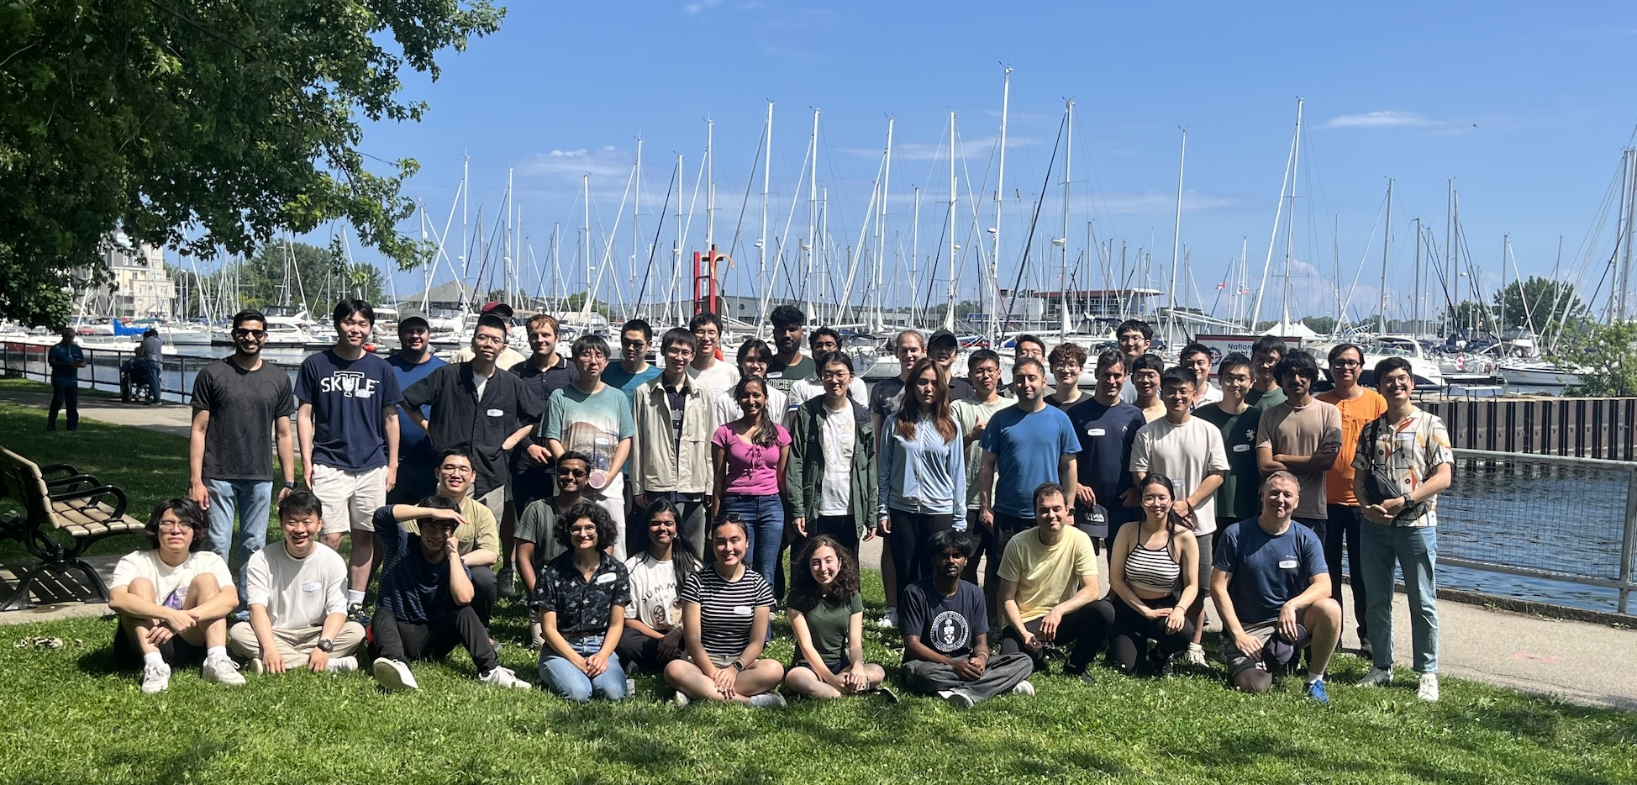
Annual Lab Picnic, 2024

Paper accepted at Symposium on VLSI Circuits 2024
R. Rangel, X. Sun, A. Barman, R. Gulve, S. Bajic, J. Wang, H. Wang, D. Lindell, K. Kutulakos, R. Genov, “23,000-Exposures/s 360fps-Readout Software-Defined Image Sensor with Motion-Adaptive Spatially Varying Imaging Speed,” IEEE Symposium on VLSI Circuits, June 2024.

Prof. Roman Genov receives Connaught Innovation Award 2024

Our latest computational camera live demonstration was well received at ISSCC 2023
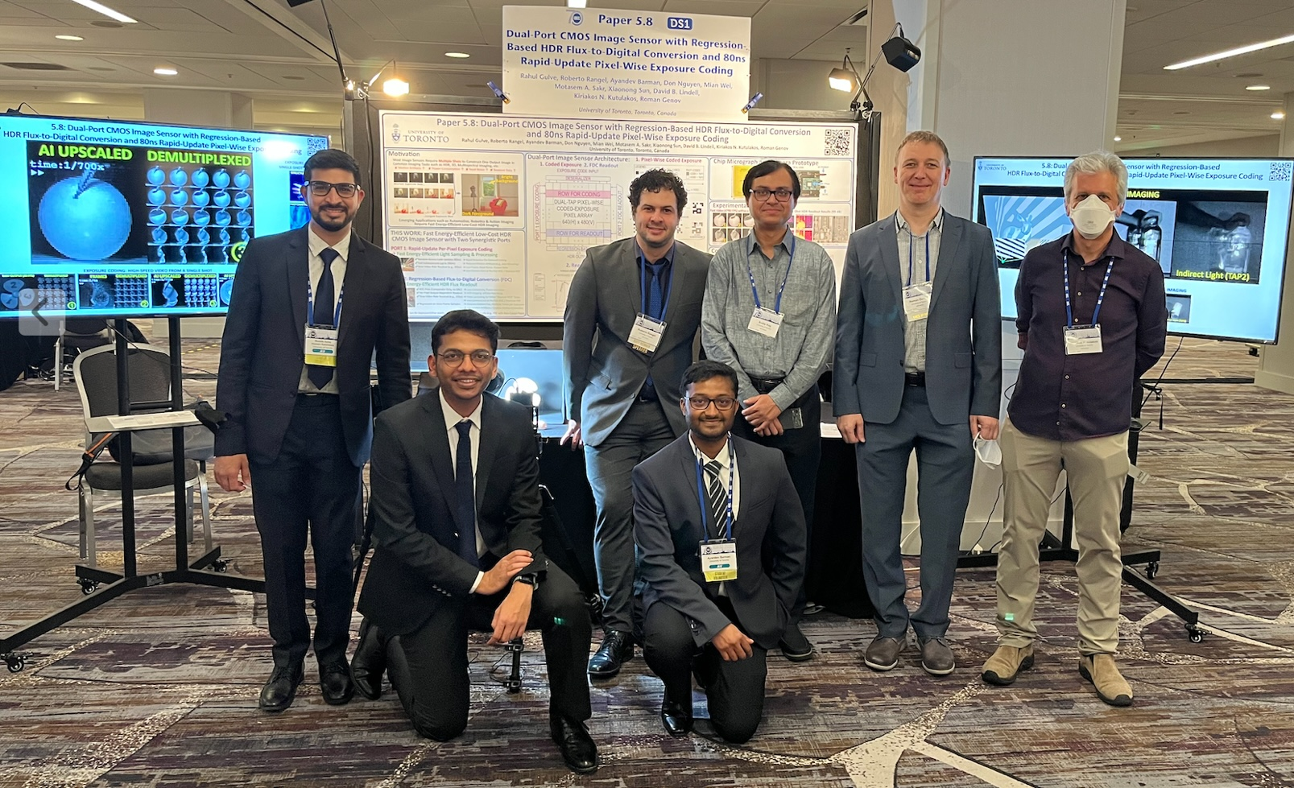

Reunion with current and former students at ISSCC 2023
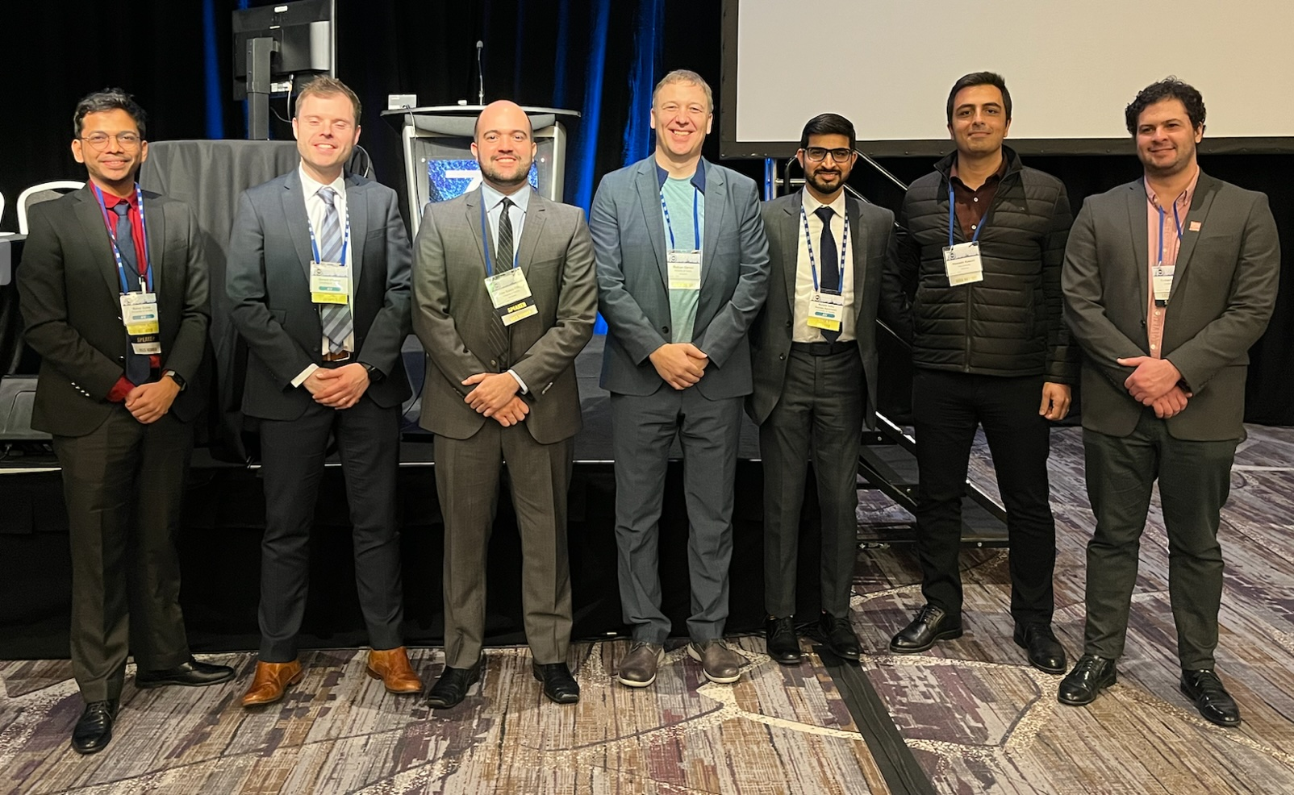

Two papers accepted at ISSCC 2023
R. Gulve, R. Rangel, A. Berman, D. Nguyen, M. Wei, M. Sakr, X. Sun, D. B. Lindell, K. N. Kutulakos, R. Genov, “Dual-Port CMOS Image Sensor with Regression-Based HDR Flux-to-Digital Conversion and 80ns Rapid-Update Pixel-Wise Exposure Coding,” IEEE International Solid-State Circuits Conference (ISSCC), San Francisco, Feb. 2023.

J. Xu, J. S. Filho, S. Nag, L. Long, C. Tejeiro, E. Hwang, G. O'Leary, Y. Huang, M. Kanchwala, M. Abdolrazaghi, C. Tang, P. Liu, Y. Sui, X. Liu, J. Zariffa, R. Genov, “Fascicle-selective Bidirectional Peripheral Nerve Interface IC with 173dB FOM Noise-Shaping SAR ADCs and 1.38 pJ/bit Frequency-Multiplying Current-Ripple Radio Transmitter,” IEEE International Solid-State Circuits Conference (ISSCC), San Francisco, Feb. 2023.

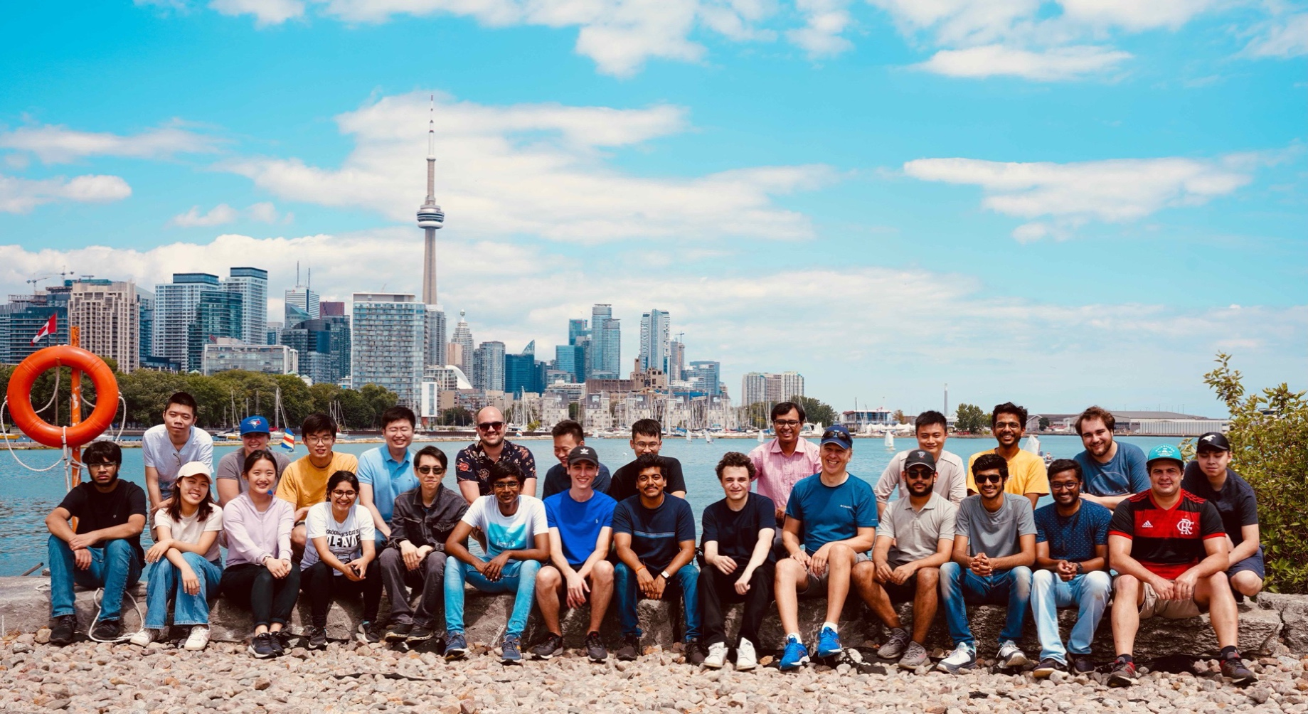
Annual Lab Picnic, 2022

Paper accepted at Symposium on VLSI Circuits 2022
R. Gulve, N. Sarhangnejad, G. Dutta, M. Sakr, D. Nguyen, R. Rangel, W. Chen, Z. Xia, M. Wei, N. Gusev, E. Y. H. Lin, W. Sun, L. Hanxu, N. Katic, A. Abdelhadi, A. Moshovos, K. N. Kutulakos, R. Genov, “A 39,000 Subexposures/s CMOS Image Sensor with Dual-tap Coded-exposure Data-memory Pixel for Adaptive Single-shot Computational Imaging,” Symposium on VLSI Circuits, Honolulu, June 2022.

Prof. Roman Genov receives Connaught Innovation Award 2022

Paper accepted at ISSCC 2021
M. ElAnsary, J. Xu, J. S. Filho, G. Dutta, L. Long, A. Shoukry, C. Tejeiro, C. Tang, E. Kilinc, J. Joshi, P Sabetian, S. Unger, J. Zariffa, P. Yoo, R. Genov, “Multi-modal Peripheral Nerve Active Probe and Microstimulator with On-chip Dual-coil Power/Data Transmission and 64 2nd-order Opamp-less ΔΣ ADCs,” IEEE International Solid-State Circuits Conference (ISSCC), San Francisco, Feb. 2021.

Prof. Roman Genov receives Connaught Innovation Award 2021

Paper accepted at ISSCC 2020
G. O'Leary, J. Xu, L. Long, J. S. Filho, C. Tejeiro, M. ElAnsary, C. Tang, H. Moradi, P. Shah, T. A. Valiante, R. Genov, “A Neuromorphic Multiplier-less Bit-Serial Weight-Memory-Optimized 1024-tree Brain State Classifier and Neuromodulation SoC with an 8-Channel Noise-Shaping SAR ADC Array,” IEEE International Solid-State Circuits Conference (ISSCC), San Francisco, Feb. 2020.

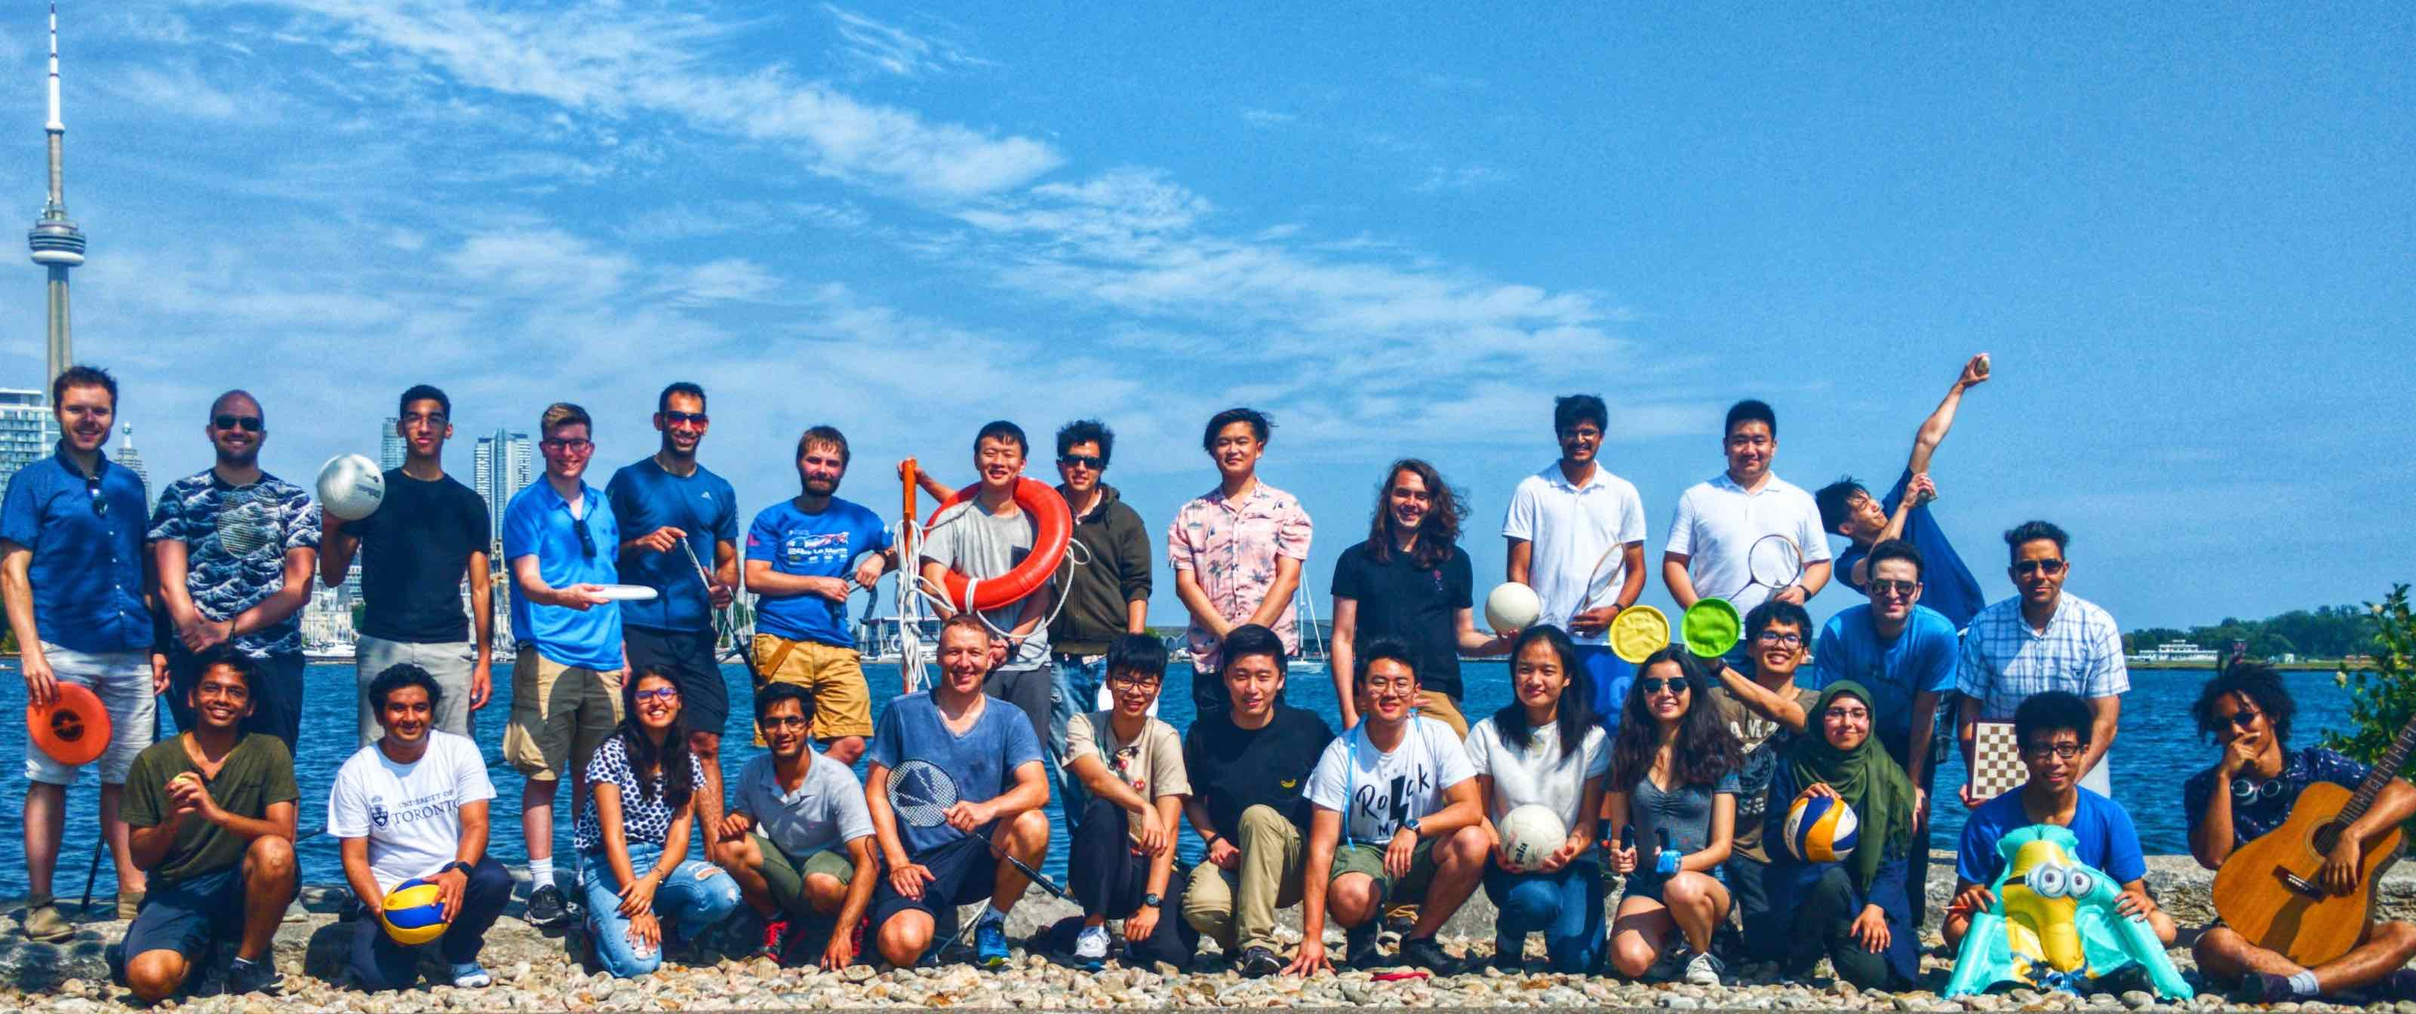
Annual Lab Picnic, 2019

C2B Computational Camera Live Demo successfully presented at ISSCC 2019
N. Sarhangnejad, N. Katic, Z. Xia, N. Gusev, G. Dutta, R. Gulve, M. Monero, M. Wei, H. Haim, D. Stoppa, K. Kutulakos, R. Genov, “Dual-Tap Pipelined-Code-Memory Coded-Exposure-Pixel CMOS Image Sensor for Multi-Exposure Single-Frame Computational Imaging,” IEEE International Solid-State Circuits Conference, Feb. 2019.
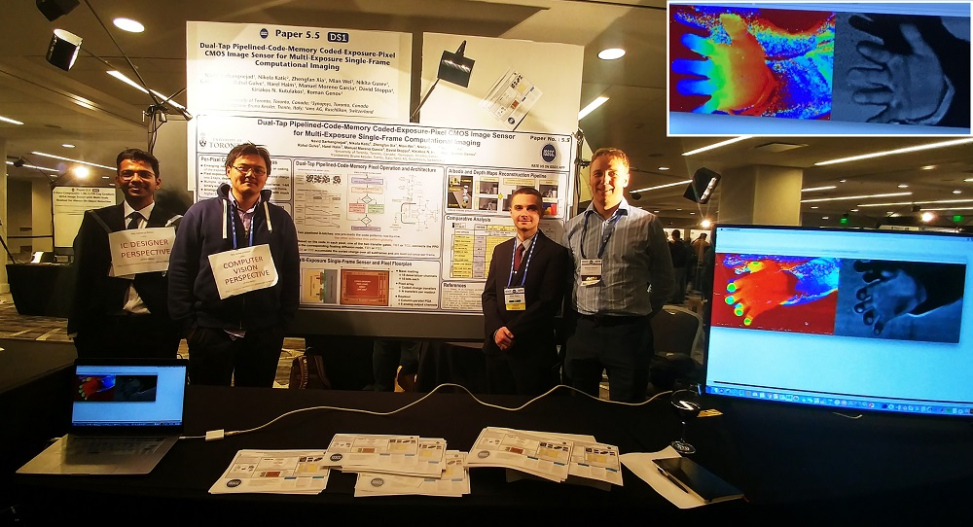
More demo videos from our C2B camera can be found here

Prof. Roman Genov receives Connaught Innovation Award 2019
Clinical Validation of an Intelligent Implantable Neurostimulator for Treating Drug-resistant Epilepsy

Two Papers Accepted at ISSCC 2019
M. R. Pazhouhandeh, G. O’Leary, D. Groppe, T. Valiante, N. Verma, R. Genov, “Adaptively Clock-boosted Auto-ranging Responsive Neurostimulator for Emerging Neuromodulation Applications,” IEEE International Solid-State Circuits Conference, Feb. 2019.

N. Sarhangnejad, N. Katic, Z. Xia, N. Gusev, G. Dutta, R. Gulve, M. Monero, M. Wei, H. Haim, D. Stoppa, K. Kutulakos, R. Genov, “Dual-Tap Pipelined-Code-Memory Coded-Exposure-Pixel CMOS Image Sensor for Multi-Exposure Single-Frame Computational Imaging,” IEEE International Solid-State Circuits Conference, Feb. 2019.

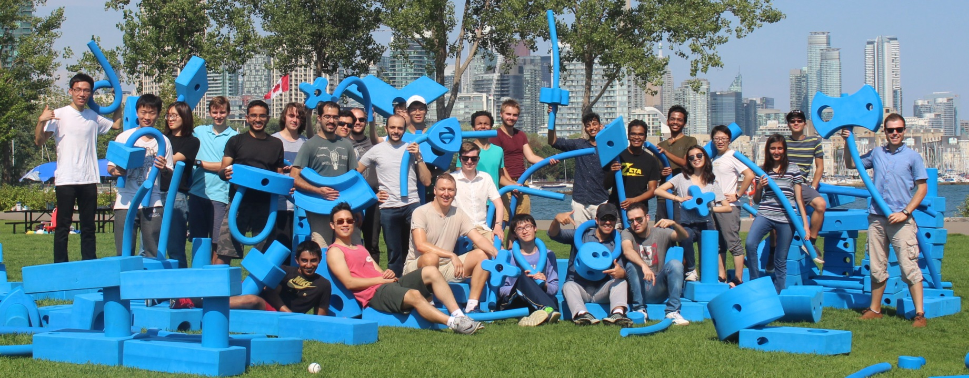
Annual Lab Picnic, 2018

Paper Accepted at ECCV 2018
M. Wei, N. Sarhangnejad, Z. Xia, H. Ke, N. Gusev, R. Genov, K. N. Kutulakos, “Coded Two-Bucket Cameras for Computer Vision,” European Conference on Computer Vision, Sept. 2018.

Paper Accepted at Symposium on VLSI Circuits 2018
M. R. Pazhouhandeh, H. Kassiri, A. Shoukry, I. Weisspapir, P. Carlen, R. Genov, “Artifact-Tolerant Opamp-less Delta-Modulated Bidirectional Neuro-Interface,” Symposium on VLSI Circuits, June 2018.

Paper Invited to the Special Issue of JSSC on Best Papers on Technology Directions from ISSCC 2018
G. O’Leary, D. Groppe, T. Valiante, N. Verma, R. Genov, “NURIP: Neural Interface Processor for Brain State Classification and Programmable-Waveform Neurostimulation,” IEEE Journal of Solid-State Circuits, 2018.

Jack Kilby Award for Outstanding Student Paper, ISSCC 2018
H. Kassiri, M. R. Pazhouhandeh, M. T. Salam, J. L. P. Velazquez, R. Genov, “All-Wireless 64-channel 0.013mm²/ch Closed-Loop Neurostimulator with Rail-to-Rail DC Offset Removal,” IEEE International Solid-State Circuits Conference, Feb. 2017.

Two Papers Accepted at ISSCC 2018
G. O’Leary, M. R. Pazhouhandeh, D. Groppe, T. Valiante, N. Verma, R. Genov, “A Recursive-memory Brain State Classifier with 32-Channel Track-and-Zoom Δ2Σ ADC and Charge-balanced Programmable-waveform Neurostimulators,” IEEE International Solid-State Circuits Conference, Feb. 2018.

M. ElAnsary, N. Soltani, H. Kassiri, R. Machadoa, S. Dufour, P. Carlen, M. Thompson, R. Genov, “50nW 5kHz-BW Opamp-less ΔΣ Impedance Analyzer for Brain Neurochemistry Monitoring,” IEEE International Solid-State Circuits Conference, Feb. 2018.

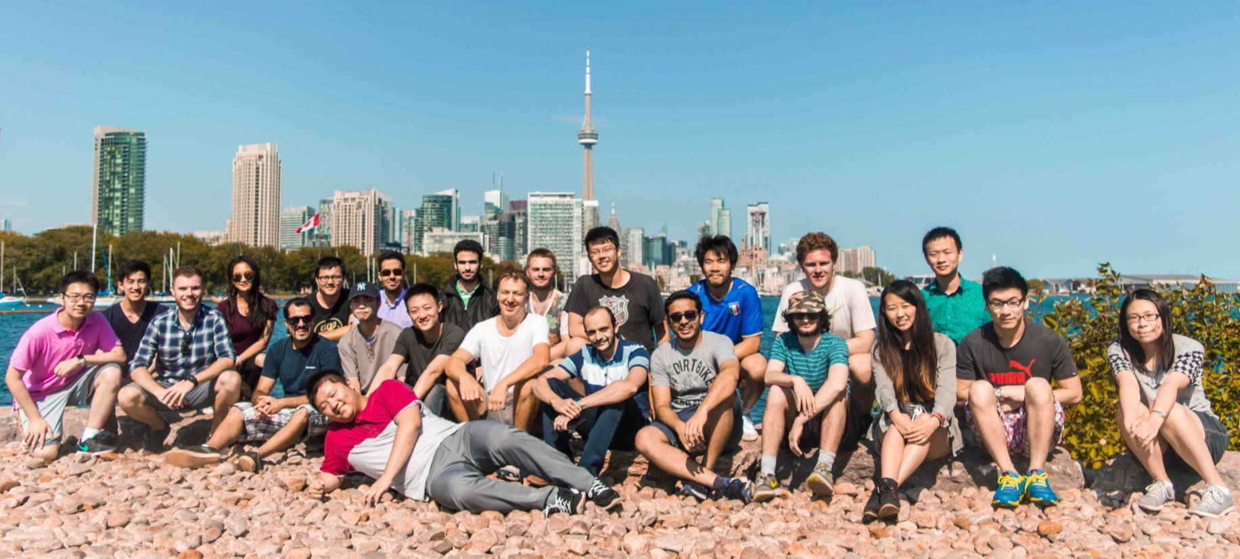
Annual Lab Picnic, 2017

Paper Invited to the Special Issue of JSSC on Best Biomedical Papers from ISSCC 2017
H. Kassiri, M. T. Salam, M. R. Pazhouhandeh, N. Soltani, J. L. Perez Velazquez, P. L. Carlen, R. Genov, “Rail-to-Rail-Input Dual-Radio 64-channel Closed-Loop Neurostimulator,” IEEE Journal of Solid-State Circuits, Oct. 2017.

Best Paper Award, IEEE TBioCAS 2017
R. Shulyzki, K. Abdelhalim, A. Bagheri, M. T. Salam, C. M. Florez, J. L. Perez Velazquez, P. L. Carlen, R. Genov, “320-Channel Active Probe for High-Resolution Neuromonitoring and Responsive Neurostimulation,” IEEE Transactions on Biomedical Circuits and Systems, Vol. 9, No. 1, pp. 34-49, Feb. 2015.

Best Paper Award in Biomedical Systems, IEEE ISCAS 2016
H. Kassiri, N. Soltani, M. T. Salam, J. L. P. Velazquez, R. Genov, “Battery-Less Modular Responsive Neurostimulator for Prediction and Abortion of Epileptic Seizures,” IEEE International Symposium on Circuits and Systems, May 2016.

Discovery Accelerator Award, NSERC 2017
http://www.nserc-crsng.gc.ca/NSERC-CRSNG/FundingDecisions-DecisionsFinancement/DiscoveryAcceleratorSupplements-SupplementsAccelerationDecouverte/index_eng.asp?Year=2017

Major Grants Awarded in 2017
“Transport-Aware Image Sensors,” Natural Sciences and Engineering Council of Canada (NSERC), Discovery Grant
“Artificially Intelligent Neurostimulators for Drug-Resistant Epilepsy,” Canadian Institutes of Health Research (CIHR), Project Grant
“Heterogeneous Integration of High-Density Analog Crossbar for Advanced Data Processing,” Natural Sciences and Engineering Council of Canada (NSERC), Strategic Project Grant
“Wireless Neurophotonic Probes for the Interrogation of Neurons in Memory Circuits,” CIHR and NSERC, Collaborative Health Research Project Grant

Selected past news:

Connaught Innovation Award 2016
Pre-market Clinical Validation of A Seizure-aborting Smart Implantable Neurostimulator for Treating Drug-resistant Epilepsy

Best Paper Award, IEEE BioCAS 2011
H. Jafari, R. Genov, “CMOS Impedance Spectrum Analyzer with Dual-Slope Multiplying ADC,” IEEE Biomedical Circuits and Systems Conference, Nov. 2011.

Best Student Paper Award, IEEE ISCAS 2009
A. Nilchi, J. Aziz, R. Genov, “CMOS Image Compression Sensor with Algorithmically-Multiplying ADCs,” IEEE International Symposium on Circuits and Systems, May 2009.

Best Paper Award in Sensory Systems, IEEE ISCAS 2009
A. Nilchi, J. Aziz, R. Genov, “CMOS Image Compression Sensor with Algorithmically-Multiplying ADCs,” IEEE International Symposium on Circuits and Systems, May 2009.

